Intelligent Transportation Systems (ITS) Analysis, Modeling, and Simulation (AMS) Community of Practice
GitHub Community User Guide

January 2026



Table of Contents
Chapter 1. Sign Up & Set Up 1
Chapter 2. Navigation & Collaboration 4
“< > Code” Page 4
“Discussions” Page 4

List of Tables
No table of figures entries found.
List of Figures
Figure 1. GitHub Signup Page 1
Figure 2. ITS AMS Community Invitation 2
Figure 3. Profile Settings 2
Figure 4. Organization Membership Visibility 3
Figure 5. ITS AMS Community Forum GitHub Homepage 4
Figure 6. Overview of the "Discussions" page 5
Figure 7. Example Discussion Thread 6

Sign Up & Set Up
To join the community, a GitHub account is required. To sign up for a GitHub account, visit GitHub and follow the steps to create an account (Figure 1). Note that GitHub requires all users to enable one or more forms of two-factor authentication (2FA). For more information on 2FA and instructions on how to configure 2FA, please visit: About 2FA. Within this link, a separate link is provided with detailed steps to configure 2FA (Configuring 2FA).

Figure 1. GitHub Signup Page
The community administrators will send an invitation to the organization email addresses on file for the community members. If you would like to join the community via a GitHub account registered to a different email, please let the administrators know.
Invited members will receive an email from “nonreply@github.com” with the subject “[GitHub] @[username] has invited you to join the FHWA/ITS_AMS_Community-of-Practice”. Once received, members can click “Join” to be admitted to the community page (see Figure 2).
The ITS AMS Community of Practice GitHub page is located at: FHWA/ITS_AMS_Community-of-Practice.
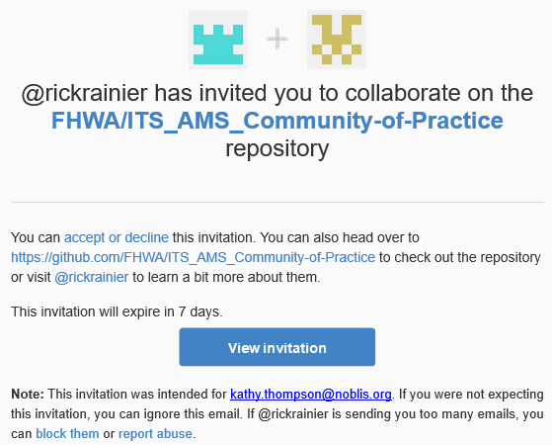
Figure 2. ITS AMS Community Invitation
Once admitted as a community member, members can manage their profile settings. Profile settings can be selected when you click on the icon in the upper right part of the page (see Figure 3). Under the status bar, please enter your affiliation (e.g., FHWA).
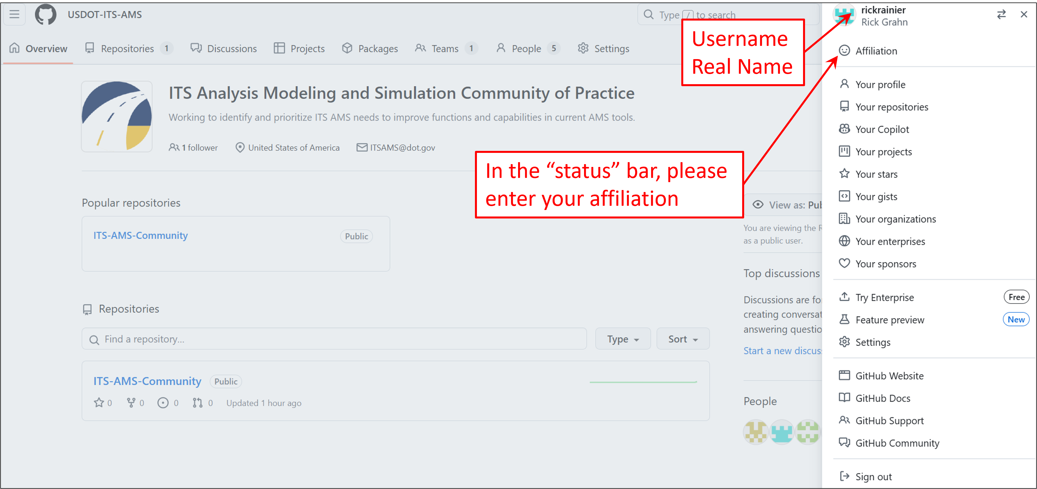
Figure 3. Profile Settings
All members of the Community will be listed as a “private” member by default, meaning your membership is only visible to other members of the community. To be listed as a public member where your membership is visible to everyone and displayed on your public profile, members will need to change their organization membership visibility. To do this, within the ITS AMS Community of Practice page, select “People”, navigate to your username, and select the “Public” Organization Visibility option (see Figure 4).

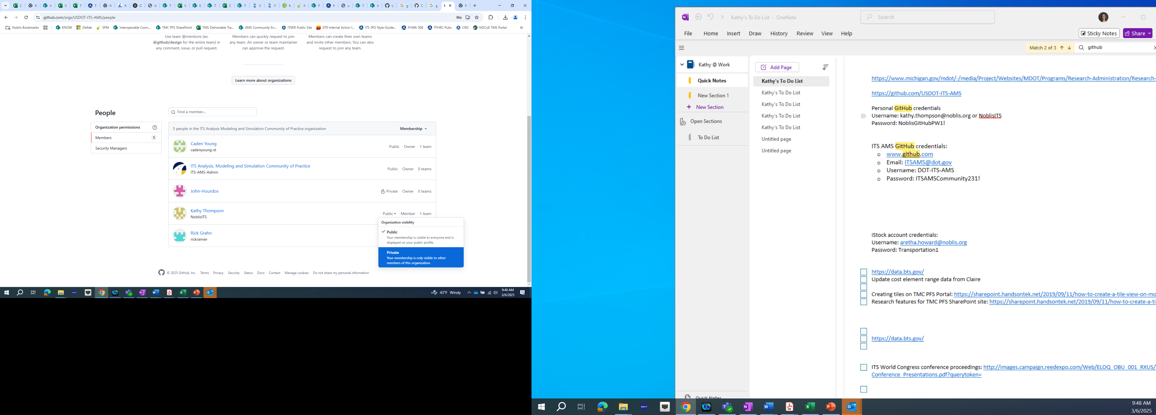
Figure 4. Organization Membership Visibility

Navigation & Collaboration
The following sections discuss the site layout and provide information about navigating the site. For the ITS AMS Community Forum, there are two important pages (“<> Code”, “Discussions”) where most of the collaboration will occur. The “<> Code” page presents an overview of the ITS AMS Program, forum goals/objectives, and expectations for community members. The “Discussions” page provides different ways to collaborate and share information with other community members.

“< > Code” Page
The ITS AMS Community Forum link (from Chapter 1) will navigate you to the ITS AMS Community homepage (see Figure 5). This page provides background information for community members to learn more about the ITS AMS program.This information can be accessed by clicking on the “<> Code” page.
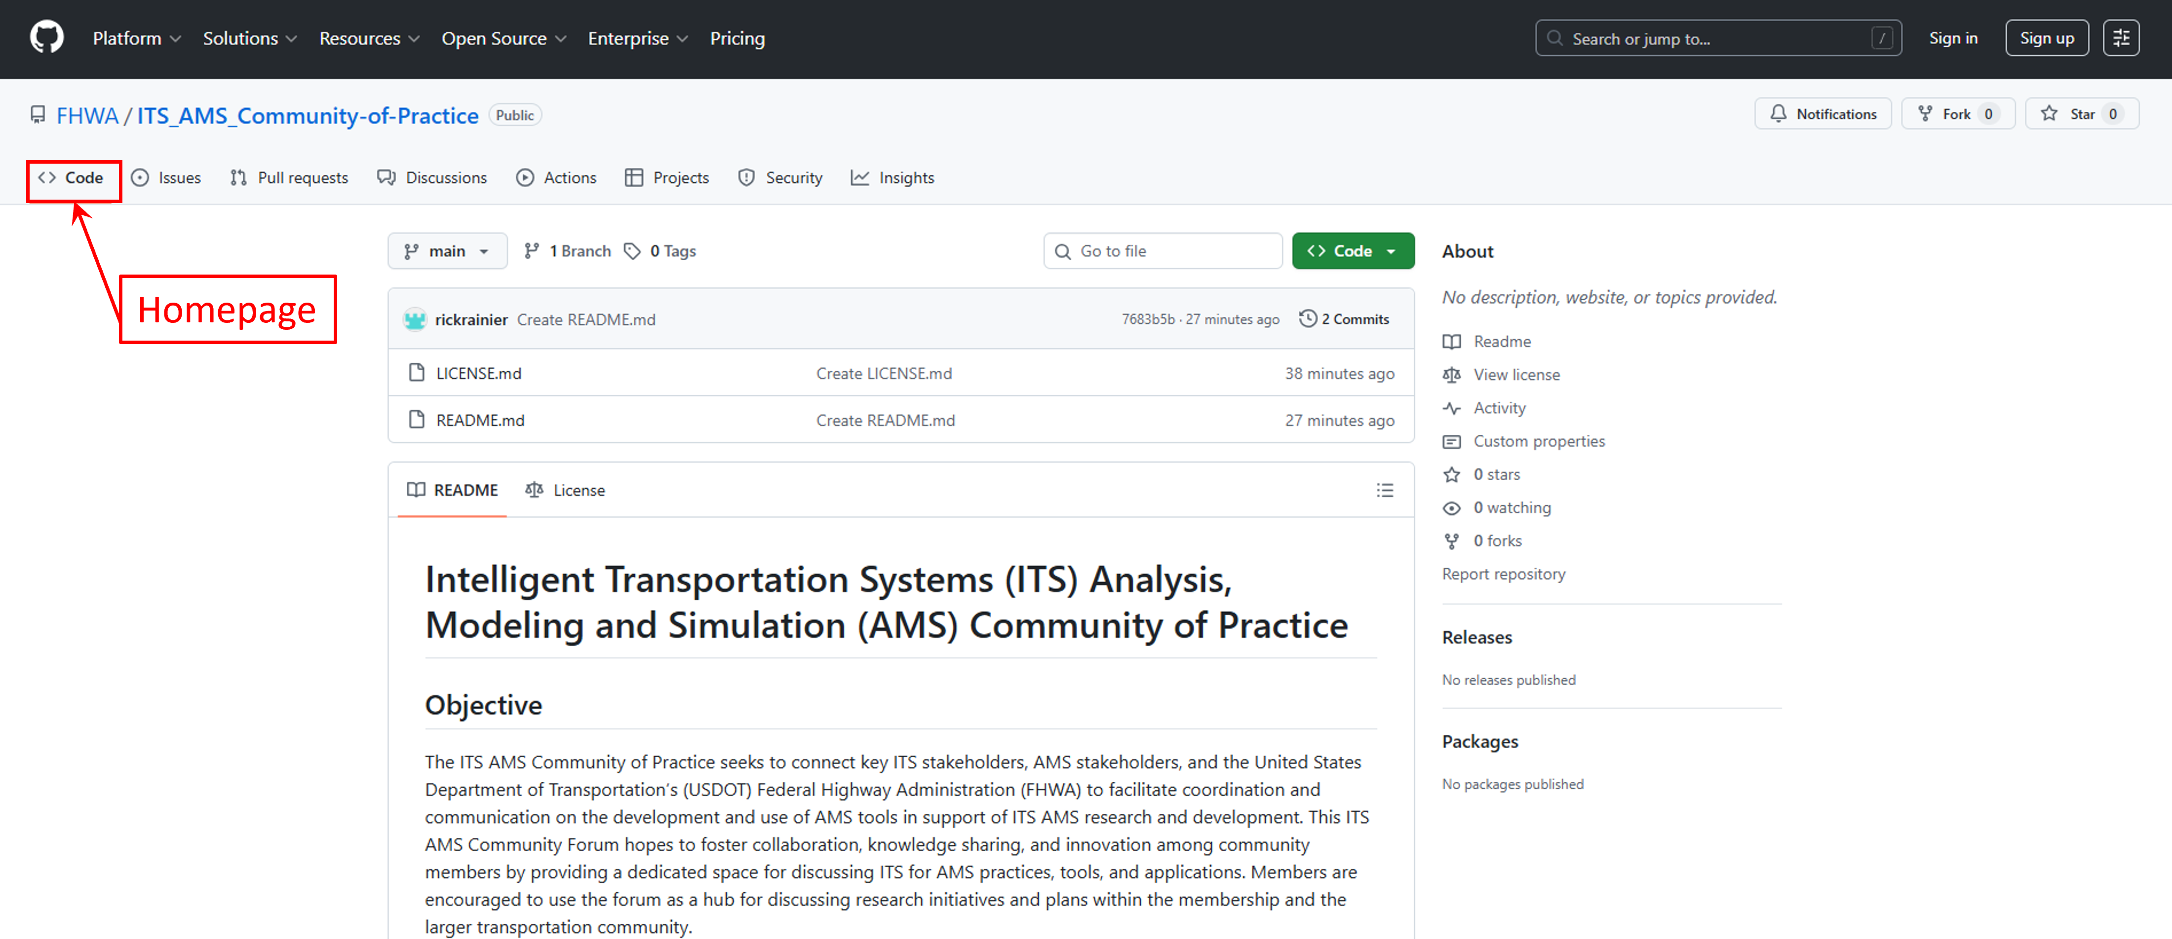
Figure 5. ITS AMS Community Forum GitHub Homepage

“Discussions” Page
The “Discussions” page is where community members can collaborate, have discussions, ask questions, share information (e.g., documents, reports, research agendas). Community members gain full access to creating discussions, asking/answering questions, sharing document, etc. once they have signed up for a GitHub account (and are signed in). New discussions can be creating by selecting the green “New discussion” tab towards the upper right part of the screen. This will them prompt you to select a category, add a title, and add body text. Once complete, click the green “Start discussion” tab at the bottom of the page. All community members can then reply/contribute to the discussion by clicking on the respective discussion. Images, documents, and other files can be added to discussion threads by drag and drop or through manual attachment. To share documents, adding attachments to specific discussion threads works well. However, if synchronous reviews are needed, it is recommended to use a different platform (google docs, SharePoint, etc.) and provide the link in the thread. Figure 6 offers a view of the discussions page.
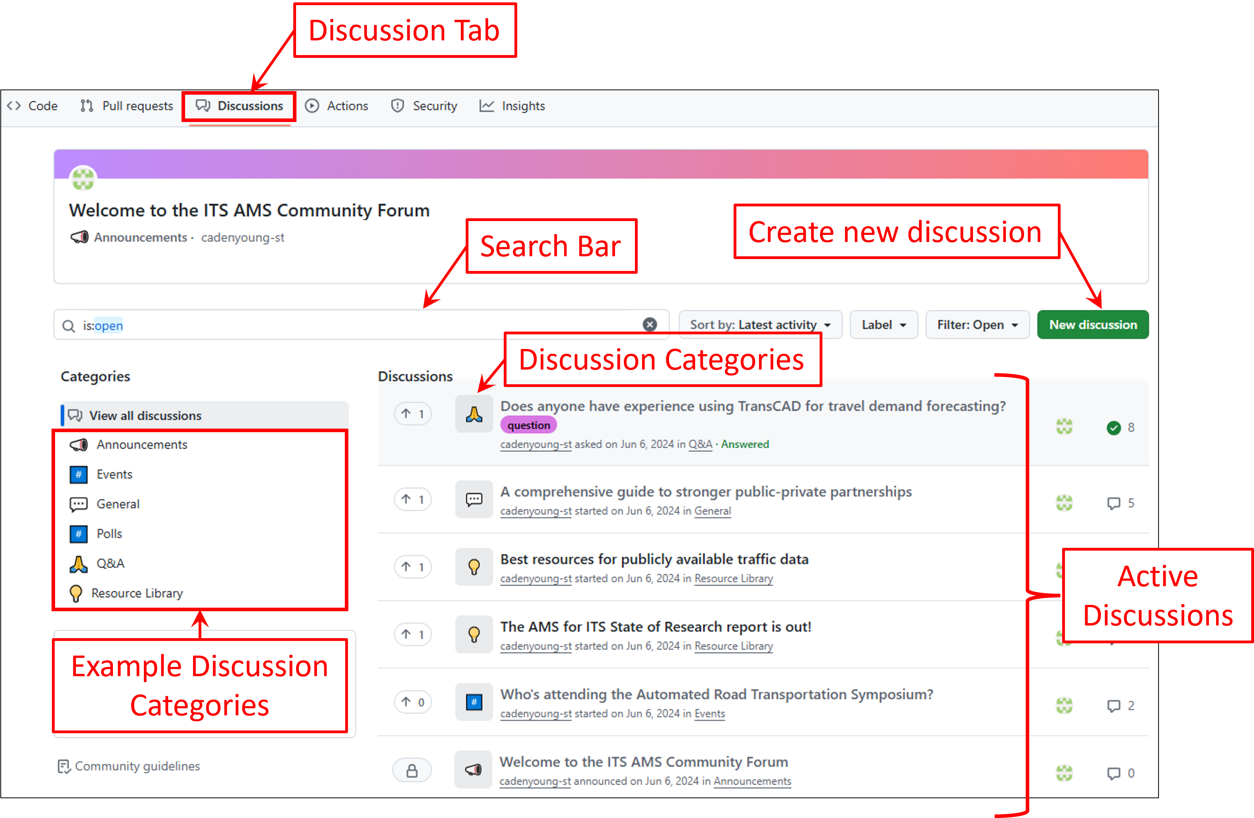
Figure 6. Overview of the "Discussions" page
In addition to creating and responding to discussion threads, community members can participate by upvoting specific discussions/answers and/or reacting to discussions/responses with emojis. Upvoting indicates support/agreement with a post and provides a way for community members to sort posts by “support” or relevance. Emojis are used to communicate different types of reactions (agree, disagree, congrats!, etc.) beyond general support for the post.
To navigate to a specific discussion, click the discussion title on the homepage (Figure 7). The selected discussion will come up on a new page that allows the participant to upvote, reply, and/or react to each response. To reply to the original post, scroll down to the bottom of the page to the “Add a comment” section. Collaborators can also reply to other replies by typing a reply immediately below the original reply. Users can also subscribe to specific discussions and receive notifications about recent discussion contributions.
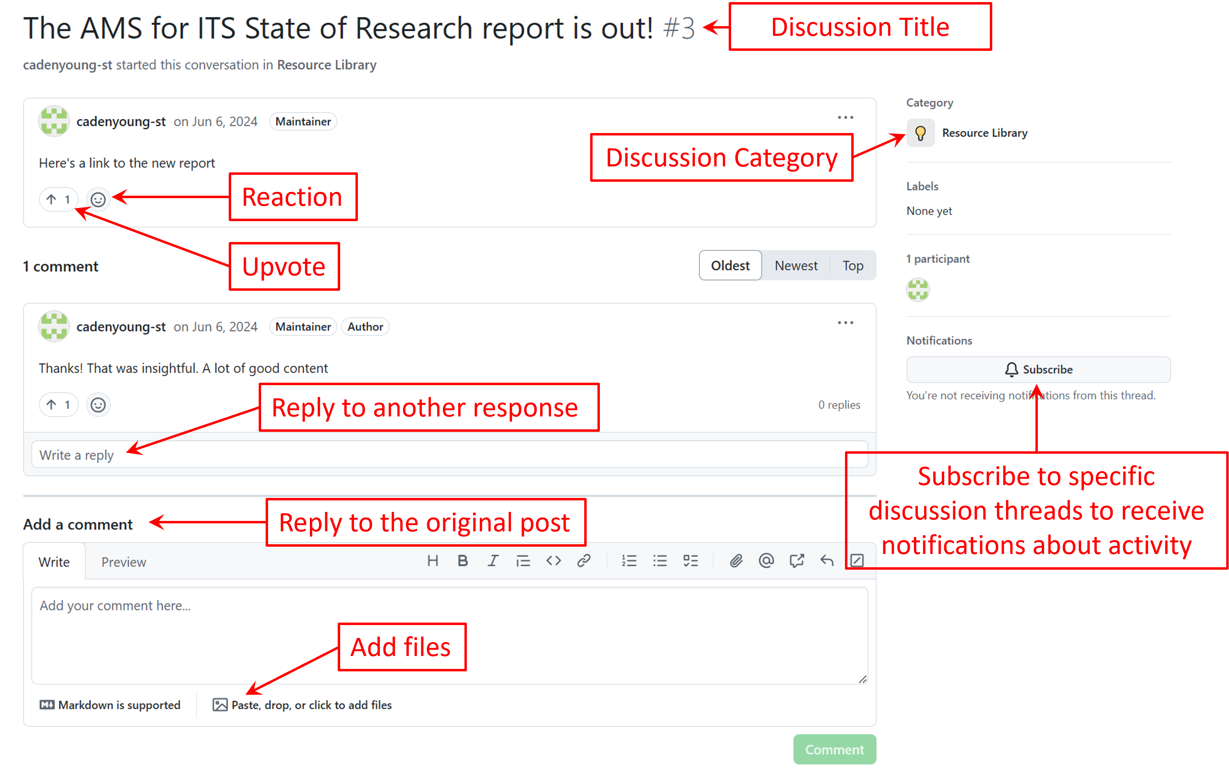
Figure 7. Example Discussion Thread

U.S. Department of Transportation
1200 New Jersey Avenue, SE
Washington, DC 20590
Toll-Free “Help Line” 866-367-7487



